**TASK REPORT**

**DATA VISUALIZATION**

**FIFA 19**



**By:**

**Mohamad Irwan Afandi**

**Data Science Student**

**Data Fellowship**

**2020**

**Chapter 2**

**Data Visualization**

FIFA 19 is one of the popular soccer game in 2019 (already update FIFA 21). In this task, I got csv data from FIFA 19 that contain 18206 players data and 87 attributes start like name, position, age, ability, club, salary, nationality and soon. Furthermore, as a data scientist we should be able to analyst that data and got some insights from it. So we can use that data to determine something interesting. For example when there is a national U19 football event and we don’t know the national player (we know just senior player), we can predict who will be the winner using that data. Just find which country has a lot of potential young players, and choose that nationality. Another example if we are to be a talent scouting, how we determine which players will be monitored before sign them to our club? we know there are a lot of potential players and we will be confused if we don’t have enough data. Based on that problems we will try to make a good decision using Tableu. Tableu is very useful to help us read the data through various type of chart. So we can understand a large scale of data as quick as we can, and also make perfect decision.

**Chapter 2**

**Progress Report**

In this chapter you will have to fill in the table below according to the progress of the project that you have made along the way. We need to know how long it takes for you and how big the effort that you have done in order to complete this task. We appreciate detailed information.

|  |  |  |  |
| --- | --- | --- | --- |
| **Day/Date** | **Task** | **Level** (easy/medium/hard) | **Comments** |
| 08/08/2020 | Determine what the problem that want to solve. | easy |  |
| 08/08/2020 | Explore how to make calculation, action, and split data in Tableu. | Medium | This is very new for me, so It took a lot of my time. |

**Chapter 3**

**Task Report**

This is my Tableu Dashboard for FIFA 19 which focus on player’s position report based on their country using geospatial data. I try to make some action like showing all players when clicking one of the country in the map. Just visit my tableu to get the experience <https://public.tableau.com/profile/mohamad.irwan.afandi#!/vizhome/FifaAnalysis_15968221940630/Dashboard1>

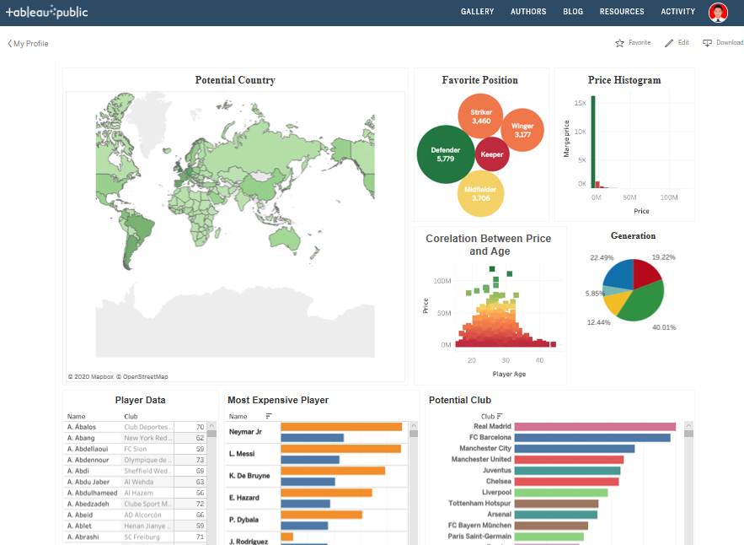

**Create Potential Country**

The problem faced when creating the map page is we only have the country name without latitude and longitude that required by the map page. The solution is make a new variable that generate the latitude and longitude based on the country name. In this page when we hover one of the area, we can get the information about the country name and the number of football player in that country.

**Favorite position**

The problem faced when creating this page is we need to group the number of position in 5 big group (keeper, defender, midfielder, winger and striker). Then add with the number of player (aggregation: sum name) to give the chart label. Now we can see that most of the player choose defender as their favorite position then striker.

**Price Histogram**

The problem faced when creating this page is we don’t have the price data in integer. The price appear in value attribute (€110.5M / €200.5K), and the challenge is we need to split the data from the symbol and also. We also need to distinguish between K and M symbol because K mean thousand and M mean million. After get the number data, times the data with 1.000 or 1.000.000 based in the symbol. Now we get an information that mostly the price of the football player under 2 million uero.

**The Correlation Between Price and Age**

We can say that the plyer’s age can determine the player price based in the chart. If the plyer is too young or too old, their market price is low.

**Generation**

The problem faced in this section is we need to create a calculation field to determine the generation based on range of age. The generation divided into 5 part : young, rookies, young star, rising star and old. This section give information about the number of young plyer lower than the old player. This should be the focus of every country to make a good academy, so the young people in that country interest in football career.

**Player Data Report**

The last is about the player data report (player data, most expensive player, and potential club) that made interactively using action. So when we click the region on the map, it will effect to this section (filter the data based on the country). This interactive dashboard make the user easier to find everything about players and club data by clicking the country.

**Conclution**

* Most footballers come from Europe and South America, Asia has very little players. Even Indonesia only has one player, E. Maulana Vikri.
* Footballers prefer choose defender as their football position, maybe because the position has a lot of slots to fill. If you often see the football match, you will not be surprised if most of manager always put 4 defender in their defensive area.
* Mostly the price of the football player under 2 million uero, if the price is greater that it. I can say that his overall skill is perfect.
* Player’s age is one of the factor to determine the price of every player, however other factor like skill, position and country may also affect.
* The number of young player (u19) in FIFA 19 is very small, lest then 6%. Maybe it because there are few young players who play regularly in senior team.
* Real Madrid is the most potential club followed by Barcelona and Manchester City, it is fair if the club has 5 stars for their average player’s skill.
* The most expensive player is Neymar (26) followed by Messi (32). We know that even though Messi older that Neymar, but his skill is brilliant.